http://blog.circuits4you.com/2015/04/atmega8-interfacing-with-16x2-lcd-in-4.html

AtMega8 Interfacing with 16x2 LCD in 4-bit Mode

In this tutorial you will learn how to interface 16x2 LCD display and similar LCDs with Atmega8 Microcontroller. You will see that how to interface LCD using only 6 IO lines. details about LCD commands and other techniques are explained in 8051 LCD interfacing  tutorial present in 89C51 tutorial section.

**Objective:**

**1. To use minimum IO lines to interface LCD.**

**2. We are using 6-IO Lines**

**3. To control display on which line it should display**

**4. Use of minimum components**

**Circuit Diagram :**

[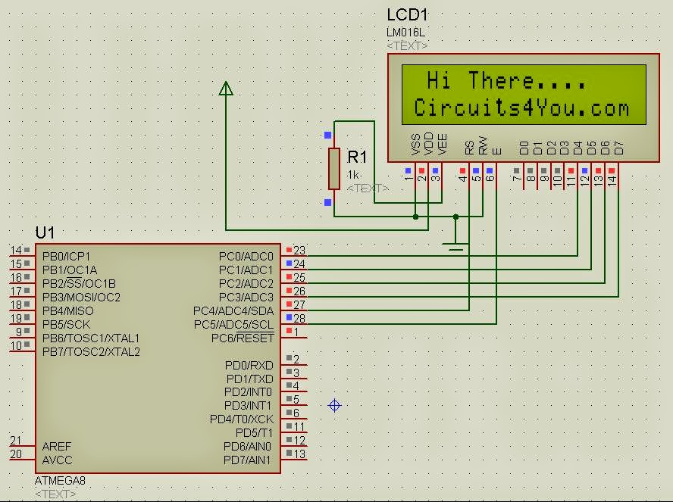](http://1.bp.blogspot.com/-rRNDtAZ6Wks/VUJMBHfX5uI/AAAAAAAAAJI/j_QFINBc8vg/s1600/4-Bit%2BLCD%2BInterface.JPG)

Connect Pin 7 and Pin8 of Atmega 8 to VCC and GND respectively apart from above connection to make it working.

**C Code, Program (AVR Studio 4):**

//=================================================================

/* 4-Bit mode 16x2 LCD Module Software */

/* 2nd Dec 2005 */

/* Copyright 2005 Circuits4You.com */

/* WWW - http://www.circuits4you.com */

/* Email - info@circuits4you.com */

/* LCD Pin-5(R/W) must be connected to ground*/

//=================================================================

#include <avr/io.h>

#include <string.h>

#define E PC5

#define RS PC4

**void** **display**(**char** string[**16**], **char** LineNo);

**void** **displaybyte**(**char** D);

**void** **dispinit**(**void**);

**void** **epulse**(**void**);

**void** **delay_ms**(**unsigned** **int** de);

//=================================================================

// Main Function

//=================================================================

**int** **main**(**void**)

{

DDRC = **0x03F**; //Set LCD Port Direction

delay_ms(**500**); //Initiaize LCD

dispinit();

delay_ms(**200**);

display(" Hi There....",**1**);

display("Circuits4You.com",**2**);

**while**(**1**);

}

//=================================================================

// LCD Display Initialization Function

//=================================================================

**void** **dispinit**(**void**)

{

**int** count;

**char** init[]={**0x43**,**0x03**,**0x03**,**0x02**,**0x28**,**0x01**,**0x0C**,**0x06**,**0x02**,**0x02**};

PORTC &= ~(**1**<<RS); // RS=0

**for** (count = **0**; count <= **9**; count++)

{

displaybyte(init[count]);

}

PORTC |= **1**<<RS; //RS=1

}

//=================================================================

// Enable Pulse Function

//=================================================================

**void** **epulse**(**void**)

{

PORTC |= **1**<<E;

delay_ms(**1**); //Adjust delay if required

PORTC &= ~(**1**<<E);

delay_ms(**1**); //Adjust delay if required

}

//=================================================================

// Send Single Byte to LCD Display Function

//=================================================================

**void** **displaybyte**(**char** D)

{

//data is in Temp Register

**char** K1;

K1=D;

K1=K1 & **0xF0**;

K1=K1 >> **4**; //Send MSB

PORTC &= **0xF0**;

PORTC |= (K1 & **0x0F**);

epulse();

K1=D;

K1=K1 & **0x0F**; //Send LSB

PORTC &= **0xF0**;

PORTC |= K1;

epulse();

}

//=================================================================

// Display Line on LCD at desired location Function

//=================================================================

**void** **display**(**char** string[**16**], **char** LineNo)

{

**int** len,count;

PORTC &= ~(**1**<<RS); // RS=0 Command Mode

**if**(LineNo==**1**)

{

displaybyte(**0x80**); //Move Coursor to Line 1

}

**else**

{

displaybyte(**0xC0**); //Move Coursor to Line 2

}

PORTC |= (**1**<<RS); // RS=1 Data Mode

len = strlen(string);

**for** (count=**0**;count<len;count++)

{

displaybyte(string[count]);

}

}

//=================================================================

// Delay Function

//=================================================================

**void** **delay_ms**(**unsigned** **int** de)

{

**unsigned** **int** rr,rr1;

**for** (rr=**0**;rr<de;rr++)

{

**for**(rr1=**0**;rr1<**30**;rr1++) //395

{

asm("nop");

}

}

}